Sample Structure : Name~Square Feet Value~Starting at price Value

Input:
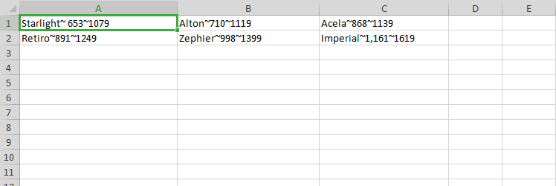

Output:

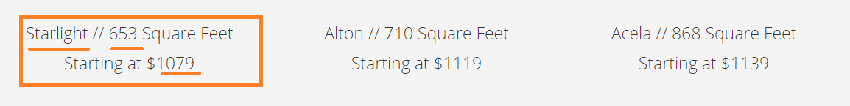

Note:

- Upload the csv files only. ( also xls,xlsx not allowed )
- Please don't write the following words to csv files ( Name: //, Square Feet and Starting at $ ). Please write the dynamic values only.
- Please don’t write the headers in csv.

4. If module section have 4images or 3section please refer following image.
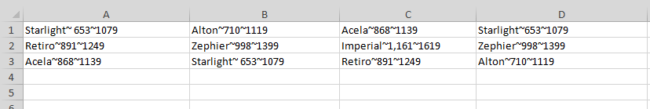

5.we can update the 2nd row data like this refer screen shot.( note: please do not enter the empty space for full row ).
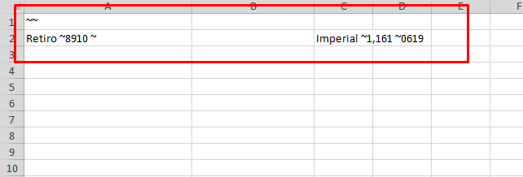

- If only update 3rd column 2nd row price then enter the csv like this refer screen shot .

